Topic: Women’s reproductive health
Level: Entry level 1 - 3 / Scottish Access 2 – National 4 / CEFR A1 - B1
Timings: 130 minutes plus extensions. Timings are flexible and teachers can break down the units into smaller chunks of learning and build in revision as required

Aims
- To allow learners to understand and be able to speak about female reproductive organs and issues to do with them.

Objectives
All learners will be able to:
- use specialist vocabulary about women’s reproductive organs
- pronounce some of these words
- give advice using should and shouldn’t

Some learners will be able to:
- write sentences giving advice about reproductive health

Introduction
This lesson is about women’s reproductive health and addresses sensitive areas that may be culturally difficult for some learners. However it provides an important area of learning and the correct vocabulary that may not have previously been taught. Please use this lesson plan sensitively and consider the learners in your class.

It is possible that your learners do not have much biological knowledge so bear this in mind particularly for Activity 1.

This lesson supports work done in the Women’s’ Health Teachers’ Pack.

Preparation
You will need:
- Resource 1: large copy to display to all learners plus 1 copy per learner
- Resources 2 and 3: 1 copy cut up per pair of learners
- Resource 4: 1 copy per pair of learners
- Resource 5 and 6: 1 copy to put on wall with questions folded over and 1 per pair of learners
- Resource 7: copy to display to all learners
- Resource 8: extension/ homework 1 copy per learner
- Highlighter pens
- Elementary learner dictionaries

Procedure
Warmer – Key words (10 minutes)
- Write 3 words on the board that will be included in today’s lesson: period; uterus; baby.
- Ask learners to make guesses about what today’s lesson might be about from those three words. Use this as an exercise to elicit anything they may know or don’t know about this subject. This will inform how you do Activity 1.

Activity 1: Vocabulary input – knowing your body (20 minutes)
- Display Resource 1 on the board and make sure learners realise that it represents the uterus: ask ‘What’s this?’ to elicit that it is the female internal reproductive organs. Possible learner answers: womb, where a baby grows.
- Hold the words (apart from period and menstrual cycle) from resource 2 up, say them then ask learners if they know what part does. Say for example, ‘Ovaries?’ Where the eggs are. ‘The uterus?’ Where the baby grows. ‘Vagina?’ Where the baby and blood comes out’. Stick the words on the picture in the correct place.
- Drill the words with the whole group then half group then small groups.
Differentiation
- If your learners have good biological knowledge, you could miss some of the stages out e.g. the whole class eliciting of meaning.
- Give learners a copy of the picture to use on their table at this stage.
Activity 2: Vocabulary – matching definitions and words (20 minutes)
- Move learners to groups of the same level. Distribute card sets (resources 2 and 3) and tell learners to match the word/ phrase with the definition.
- Learners can use bilingual or elementary dictionaries if required. Feedback correct answers by nominating learners to say the word and definitions or show the correct version on the board.
- Tell learners to place resource 3 cards face down on the table and with their partner to turn over a card and then say the word or phrase that matches the definition.
- Remove the copy of resource 1 with the answers from the board. Give learners a copy of resource 1 then ask them to match the word cards to the picture.
- Show resource 1 again to check and ask learners to stick or write the words in the correct place on the diagram.
Differentiation
- Low-level learners: limit the vocabulary to uterus, vagina and ovary.
- Once the stronger learners are matching the words and definitions, support learners to do the matching activity.

Activity 3: Listening to advice about keeping clean and healthy (15 minutes)
- Show the picture of nurse Chan and the title from resource 4 and elicit some advice she might give about keeping clean and healthy.
- Show the first sentence of true / false sentence from resource 4 then play up to that point and elicit from learners whether it’s true or false (true).
- Play the audio through with learners ticking for true.
- Ask learners to compare with a partner then play again.
- Feedback answers on board, elicit the correct answers and show on board.

Differentiation
- Higher level learners: if they finish quickly ask them to correct the false sentences.
- Lower level learners: before listening, sit with them and assist them to read the text.

Activity 4: Reading and writing - running dictation (25 minutes)
- Put learners into two groups of the same level. Within the groups put the learners in pairs then nominate one learner as the ‘writer’ and the other learner is the ‘reader’.
- Get learners to do the running dictation (see box below). The lower level-learners will use resource 5 (Periods) and the higher level learners will use resource 6 (Smear tests).

Tip! Running dictations
- Stick the two texts on the wall at the front of the class with the questions folded under, sufficiently far away from the ‘writers’ so that they can’t read it.
- The ‘readers’ must go up to their allocated text, read a line and remember it, then go back to their ‘writer’ and tell him / her the line. The ‘writer’ must write it down. The ‘reader’ returns to the text and repeats with the second line.
- There are some rules; no shouting is allowed. The readers cannot write anything down. Everyone must be careful and abide by health and safety rules (make sure there are no trip hazards between the readers and the writers.)
- The winning pair is the pair that finishes first with reasonable accuracy.
- Once they have finished the running dictation, give the lower level learners a copy of resource 5 and the higher levels resource 6 and ask them to compare and check what they wrote.
- Then ask learners to answer the questions. Monitor and correct answers.
Differentiation
Lower level learners: use only 1 text for the running dictation. You could use the other text in a different session.
Activity 5: Speaking – telling their partner about the text (15 minutes)
- Now pair the learners who read resource 5 (Periods) together with someone who read resource 6 (Smear tests).
Tip! A quick way of doing this is to point to all the learners who read resource 5 in turn, giving each of them a number (e.g. 1 to 6 if there were 6 on this team). Repeat this with all the learners who read Resource 6, using the same numbers (e.g. 1 to 6 again). Ask everyone to stand and to go and sit with the person with the same number.
- Ask learners to tell their new partner about the text.
- Feedback answers to both texts. You could do this by showing or giving learners in pairs the correct answers.
Activity 6: Giving advice (10 minutes)
- Move learners to groups of the same level. Show the picture of Maya from resource 7 and elicit some of the advice nurse Chan gave.
- In pairs tell learners to practise giving advice to Maya.
- They can also give advice about other texts they have read.
Differentiation
Learners could write their advice.

Cooler (15 minutes)
- Put learners in 2 or 3 mixed level teams and ask them to write some quiz questions for the other teams using resources 1, 2 and 3.

Extension activities/ Homework
- Three words: ask learners to choose the three most important words from the session and share with a partner why those words are important to them.
- Using the resources and the vocabulary learned in the session learners make a poster for their wing or the classroom wall about one aspect of reproductive health covered. Put learners in groups and ask them to choose different information so the posters are different.
- Resource 8 gap-fill: could be used as homework or as revision in a different session. For lower level learners, give the words needed for the spaces.

Answer key
Resource 1
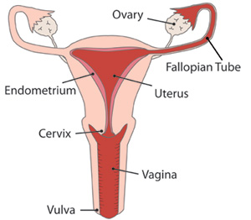

Resource 2 and 3
vulva | external female parts around the vagina
vagina | tube shaped part between the cervix and the uterus
uterus | the part where a baby grows
fallopian tube | carries the egg from the ovary to the uterus
ovary | produces eggs
period | time when a woman bleeds from her vagina every month
menstrual cycle | time between periods – about 28 days
tampon | material you put inside your vagina to collect blood during your period
sanitary towel | towel you put in your knickers to collect blood during your period

Resource 4
- gently wash your vagina and vulva everyday True
- change your underwear every two days False
- see the nurse if you have your period False
- see the nurse if you have any pain True
- change your tampon every 6 hours when you have a period False
- use soap False (use gentle soap with no strong perfume)
- forget to remove a tampon at the end of your period True
- leave your sanitary towel for 24 hours False

Resource 5
Periods last 28 days. False
The menstrual cycle is about 28 days. True
If you are stressed you can miss a period. True
The menstrual cycle is about 3 – 7 days. False
If you are worried about you periods, you can see a nurse. True
Periods last 3 – 7 days. True
Resource 6
A = 4
B = 2
C = 1
D = 7
E = 6
F = 3
G = 5

Resource 8
- know
- cervix
- smear
- normal
- healthy
- test

Transcript
Audio: Nurse Chan gives advice

Hi! Nurse Chan here with some advice about keeping clean and healthy.
You should gently wash the area around your vagina and vulva and change your underwear every day. If you notice any change in the vaginal area or if you have any soreness or itching you should see the nurse. When you have your period, change your tampon at least every 3 hours.
And here are some things you definitely shouldn’t do: don’t use strong soap with lots of perfume or forget to remove a tampon at the end of your period. If you use sanitary towels you shouldn’t leave them for more than about 12 hours.

Resource 1

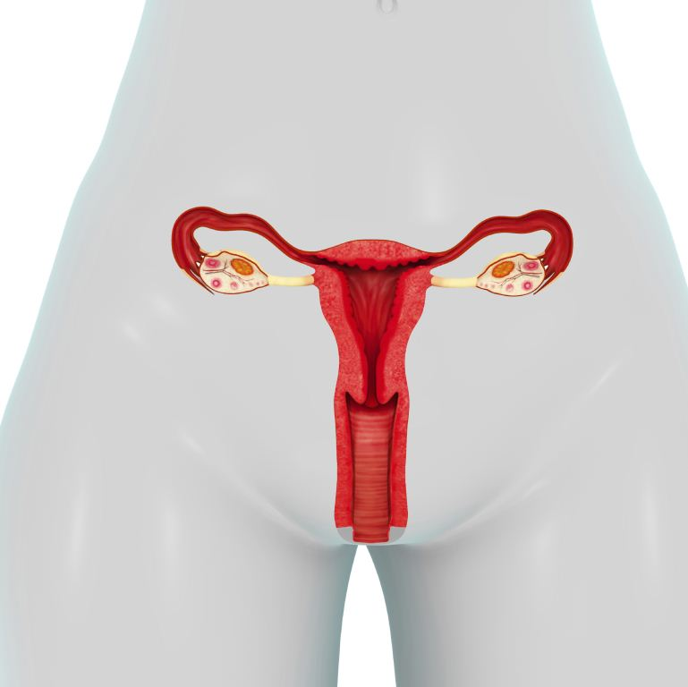

Resource 2
vulva
vagina
cervix
uterus
fallopian tubes
ovary
period
menstrual cycle
tampon
sanitary towels

Resource 3
external female parts around the vagina
tube between the cervix and the uterus
the part where a baby grows
carries the egg from the ovary to the uterus
produce eggs
time when a woman bleeds from her vagina every month
time between periods – about 28 days
material you put inside your vagina to collect blood during your period
towel you put in your knickers to collect blood during your period

Resource 4 – Keeping clean and healthy

Listen to nurse Chan and tick true or false

Nurse Chan gives advice
You need to look after your vagina by keeping clean and staying healthy.

What can you do?
You should:
- gently wash your vagina and vulva everyday
- change your underwear every two days
- see the nurse if you have your period
- see the nurse if you have any pain
- change your tampon every 6 hours when you have a period.
You should not:
- use soap
- forget to remove a tampon at the end of your period
- leave your sanitary towel for 24 hours.

Resource 5

Periods and the Menstrual Cycle

Periods last three to seven days. The menstrual cycle is about 28 days but it’s fine to have a cycle that is longer or shorter.

If your periods change and you are worried you can have a check up with the nurse to make sure everything is alright.

If you miss two or three periods and you are not pregnant, have a check up with the nurse.

Sometimes women miss periods because they are stressed or have done too much exercise.

If you are worried about very heavy bleeding during your period you can talk to a nurse or doctor.

True or false?
- Periods last 28 days.
- The menstrual cycle is about 28 days.
- If you are stressed you can miss a period.
- The menstrual cycle is about 3 – 7 days.
- If you are worried about you periods, you can see a nurse.
- Periods last 3 – 7 days.

Resource 6

What you need to know about having a
smear test

Regular smear tests are one way of making sure women stay healthy.

This test checks your cervix is normal and healthy. It’s to make sure you don’t have cancer of the cervix.

If you are between 20 – 64 years old, you can have a cervical smear test every 3 to 5 years.

The test checks that all your cells are normal.

If you are in prison for a long time you can have a smear test. When you leave prison your doctor’s surgery will invite you to have a smear test.

Match the question with the answer about the text
questions | answers
A. Why do women have a smear test? | 1.No, it can be a bit uncomfortable
B. What is a cervix? | 2. Is the lower part of the uterus
C. Does the test hurt? | 3. The doctor or nurse gently remove some cells from the cervix and sends them to the hospital to be checked
D. Who does the test? | 4. To check that the cervix is healthy and all the cells are normal
E. Will I have to undress? | 5. You get the results a few weeks later
F. What happens during the test? | 6. You undress from the waist down and then lie down on a bed. You can cover up with a towel.
G. When do I get the results? | 7. A doctor or nurse will do the test and you can ask for a female doctor or nurse

Resource 7



This is Maya

Maya wants advice about female health. What advice can you give?

- Maya should….

- Maya should not….

Resource 8

Fill the gaps and put the words in the right place.

What you ¹⁾……….to know about having a
smear test

This test checks your ²⁾……………… is normal and healthy. It’s to make sure you don’t have cancer of the cervix.

If you are between 20 – 64 old, you can have a cervical ³⁾……………. test every 3 to 5 years.

The test checks that all your cells are ⁴⁾……….... and helps you stay ⁵⁾………….. by checking there are no abnormal cells.

If you are in prison for a long time you can have a smear test. When you leave prison your doctor’s surgery will invite you to have a smear ⁶⁾………......

